
Department of

ACADEMIC YEAR: 2024 – 25

Name & Register No of the Candidate:
Course Code & Title:
Date of Issue: 16.10.2024 |  |  |  | Date of Submission:29.10.2024
Year / Dept. / Sem / Section: III / / V /
Assignment: II
Reference(s):
Marks Details
Q. No | 1 | 2 | 3 |  | 4 | 5 | Total (25)
COs
Marks Obtained

Course In-charge


Rubrics for Assignment Evaluation

Criterion | Weightage | Exemplary (5) | Excellent (4) | Adequate (3) | Average (2) | Inadequate (1) | Marks Obtained
Relevance of Content | 5 | Writing shows high degree of attention to logic and reasoning of points. | Writing is logically organized with ideas and paragraphs. | Writing is coherent and logically organized. | Some points remain misplaced and stray from the topic. | Writing lacks logical organization.
Creativeness | 5 | Content indicates synthesis of ideas, in depth analysis and evidences. | Content indicates original thinking and develops ideas with sufficient and  firm evidence. | Content indicates thinking and reasoning applied with original  thought. | Content shows average thinking and reasoning. | Shows some thinking and reasoning but most ideas are  underdeveloped.
Clarity of content | 5 | Reveals high degree of critical thinking | Critical thinking is weaved into points | Some critical  thinking is present | Critical thinking  lacks detailed development. | Ideas are vague with  little evidence of critical thinking.
Grammar & Style | 5 | Creative use of sentence structure | Excellent use of sentence structure | Adequate use of sentence structure | Average use of sentence structure | Inadequate use of sentence structure
References | 5 | Adequate, complete and standard references | Adequate and complete references but substandard | Adequate but substandard and  incomplete references | Adequate and incomplete references | Inadequate and incomplete references
Total Marks (out of 25)

Signature of the Evaluator with date

Login page:

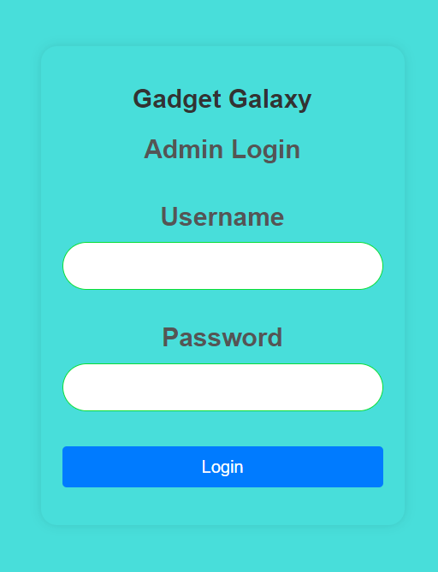

HomePage:


Product Page:
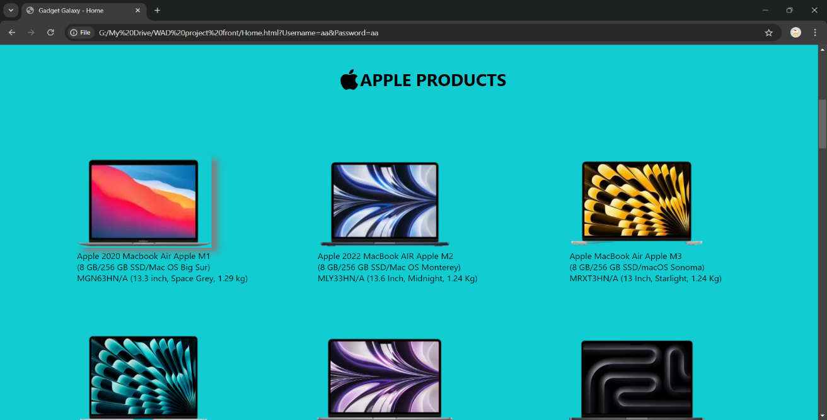

Manage product:
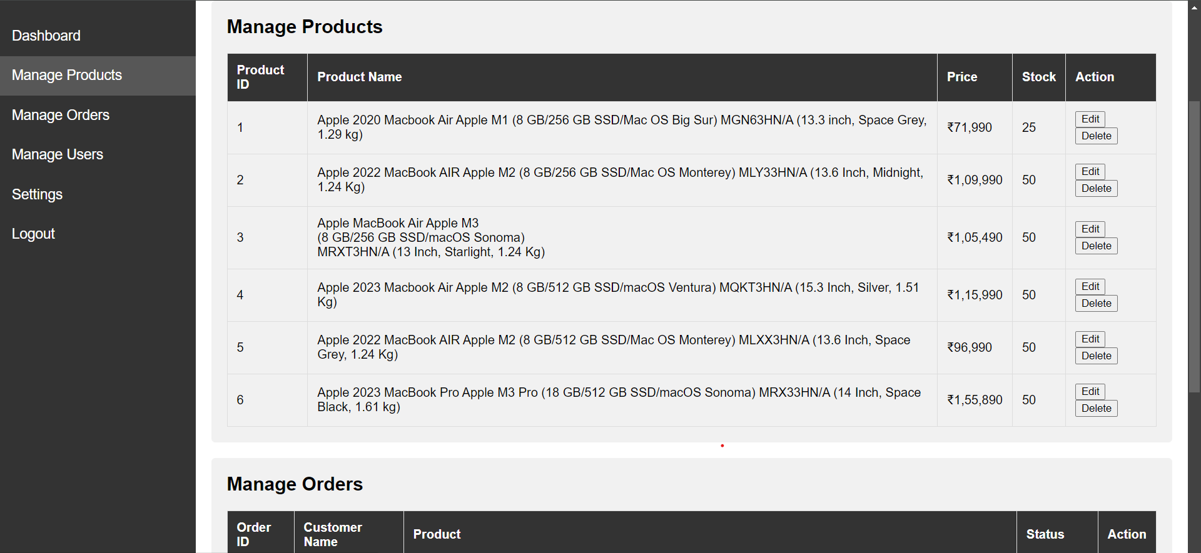
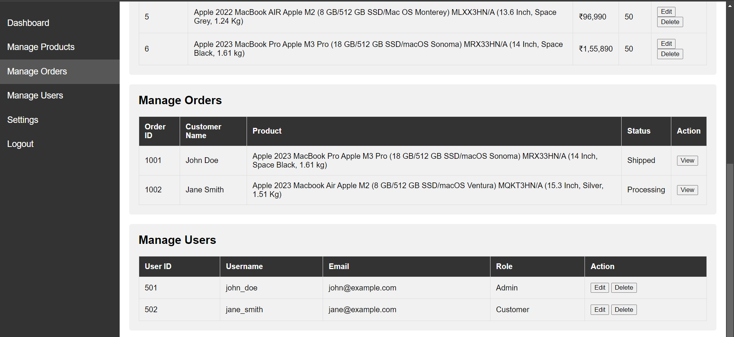
Manage Order:

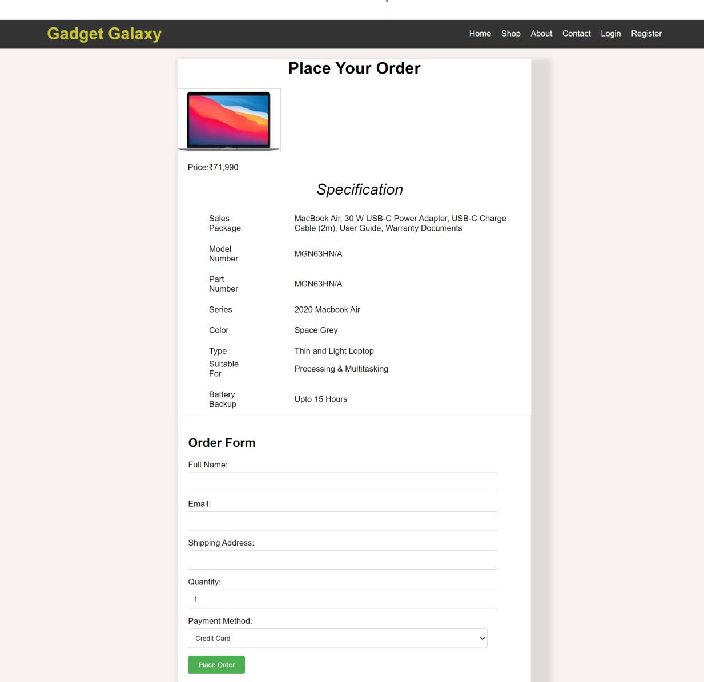
Order page:

Loginservlet.java

import java.io.IOException;

import java.io.PrintWriter;

import java.sql.Connection;

import java.sql.PreparedStatement;

import java.sql.ResultSet;

import java.sql.SQLException;

import javax.servlet.ServletException;

import javax.servlet.annotation.WebServlet;

import javax.servlet.http.HttpServlet;

import javax.servlet.http.HttpServletRequest;

import javax.servlet.http.HttpServletResponse;

import javax.servlet.http.HttpSession;

@WebServlet("/LoginServlet")

public class LoginServlet extends HttpServlet {

protected void doPost(HttpServletRequest request, HttpServletResponse response) throws ServletException, IOException {

String username = request.getParameter("Username");

String password = request.getParameter("Password");

try (Connection conn = DatabaseConnection.getConnection()) {

String sql = "SELECT * FROM users WHERE username = ? AND password = ?";

PreparedStatement stmt = conn.prepareStatement(sql);

stmt.setString(1, username);

stmt.setString(2, password);

ResultSet rs = stmt.executeQuery();

PrintWriter out = response.getWriter();

if (rs.next()) {

// Login success: Create a session and redirect to home page

HttpSession session = request.getSession();

session.setAttribute("username", username);

response.sendRedirect("Home.jsp");

} else {

// Login failure: Redirect to login page with an error

response.sendRedirect("login.jsp?error=invalid");

}

} catch (SQLException e) {

e.printStackTrace();

}

}

}

HomeServlet.java

import java.io.IOException;

import java.sql.Connection;

import java.sql.PreparedStatement;

import java.sql.ResultSet;

import java.sql.SQLException;

import java.util.ArrayList;

import java.util.List;

import javax.servlet.ServletException;

import javax.servlet.annotation.WebServlet;

import javax.servlet.http.HttpServlet;

import javax.servlet.http.HttpServletRequest;

import javax.servlet.http.HttpServletResponse;

@WebServlet("/products")

public class ProductServlet extends HttpServlet {

protected void doGet(HttpServletRequest request, HttpServletResponse response) throws ServletException, IOException {

List<Product> products = new ArrayList<>();

try (Connection conn = DatabaseConnection.getConnection()) {

String sql = "SELECT * FROM products";

PreparedStatement stmt = conn.prepareStatement(sql);

ResultSet rs = stmt.executeQuery();

while (rs.next()) {

Product product = new Product();

product.setId(rs.getInt("id"));

product.setName(rs.getString("name"));

product.setPrice(rs.getDouble("price"));

product.setDescription(rs.getString("description"));

product.setImageUrl(rs.getString("imageUrl"));

products.add(product);

}

} catch (SQLException e) {p

e.printStackTrace();

}

// Set products in request scope and forward to JSP

request.setAttribute("products", products);

request.getRequestDispatcher("products.jsp").forward(request, response);

}

}

Orderservlet.java

import java.io.IOException;

import java.sql.Connection;

import java.sql.PreparedStatement;

import java.sql.SQLException;

import javax.servlet.ServletException;

import javax.servlet.annotation.WebServlet;

import javax.servlet.http.HttpServlet;

import javax.servlet.http.HttpServletRequest;

import javax.servlet.http.HttpServletResponse;

@WebServlet("/placeOrder")

public class OrderServlet extends HttpServlet {

protected void doPost(HttpServletRequest request, HttpServletResponse response) throws ServletException, IOException {

String productName = "ASUS TUF Gaming F17"; // hardcoded for this example

String customerName = request.getParameter("name");

String email = request.getParameter("email");

String address = request.getParameter("address");

int quantity = Integer.parseInt(request.getParameter("quantity"));

String paymentMethod = request.getParameter("payment");

try (Connection conn = DatabaseConnection.getConnection()) {

String sql = "INSERT INTO orders (product_name, customer_name, email, shipping_address, quantity, payment_method) VALUES (?, ?, ?, ?, ?, ?)";

PreparedStatement stmt = conn.prepareStatement(sql);

stmt.setString(1, productName);

stmt.setString(2, customerName);

stmt.setString(3, email);

stmt.setString(4, address);

stmt.setInt(5, quantity);

stmt.setString(6, paymentMethod);

int rowsInserted = stmt.executeUpdate();

if (rowsInserted > 0) {

// Redirect to order confirmation page with success message

response.sendRedirect("orderConfirmation.jsp?status=success");

} else {

response.sendRedirect("orderConfirmation.jsp?status=error");

}

} catch (SQLException e) {

e.printStackTrace();

response.sendRedirect("orderConfirmation.jsp?status=error");

}

}

}

Product Management Servlet

import java.io.IOException;

import java.sql.Connection;

import java.sql.PreparedStatement;

import java.sql.ResultSet;

import java.sql.SQLException;

import java.util.ArrayList;

import java.util.List;

import javax.servlet.ServletException;

import javax.servlet.annotation.WebServlet;

import javax.servlet.http.HttpServlet;

import javax.servlet.http.HttpServletRequest;

import javax.servlet.http.HttpServletResponse;

@WebServlet("/products")

public class ProductServlet extends HttpServlet {

protected void doGet(HttpServletRequest request, HttpServletResponse response) throws ServletException, IOException {

List<Product> products = new ArrayList<>();

try (Connection conn = DatabaseConnection.getConnection()) {

String sql = "SELECT * FROM products";

PreparedStatement stmt = conn.prepareStatement(sql);

ResultSet rs = stmt.executeQuery();

while (rs.next()) {

Product product = new Product();

product.setId(rs.getInt("id"));

product.setName(rs.getString("name"));

product.setPrice(rs.getDouble("price"));

product.setStock(rs.getInt("stock"));

products.add(product);

}

} catch (SQLException e) {

e.printStackTrace();

}

request.setAttribute("products", products);

request.getRequestDispatcher("products.jsp").forward(request, response);

}

protected void doPost(HttpServletRequest request, HttpServletResponse response) throws ServletException, IOException {

String action = request.getParameter("action");

try (Connection conn = DatabaseConnection.getConnection()) {

if ("add".equals(action)) {

String name = request.getParameter("name");

double price = Double.parseDouble(request.getParameter("price"));

int stock = Integer.parseInt(request.getParameter("stock"));

String sql = "INSERT INTO products (name, price, stock) VALUES (?, ?, ?)";

PreparedStatement stmt = conn.prepareStatement(sql);

stmt.setString(1, name);

stmt.setDouble(2, price);

stmt.setInt(3, stock);

stmt.executeUpdate();

} else if ("delete".equals(action)) {

int id = Integer.parseInt(request.getParameter("id"));

String sql = "DELETE FROM products WHERE id = ?";

PreparedStatement stmt = conn.prepareStatement(sql);

stmt.setInt(1, id);

stmt.executeUpdate();

}

} catch (SQLException e) {

e.printStackTrace();

}

response.sendRedirect("products");

}

}

Order Management Servlet.java

import java.io.IOException;

import java.sql.Connection;

import java.sql.PreparedStatement;

import java.sql.ResultSet;

import java.sql.SQLException;

import java.util.ArrayList;

import java.util.List;

import javax.servlet.ServletException;

import javax.servlet.annotation.WebServlet;

import javax.servlet.http.HttpServlet;

import javax.servlet.http.HttpServletRequest;

import javax.servlet.http.HttpServletResponse;

@WebServlet("/orders")

public class OrderServlet extends HttpServlet {

protected void doGet(HttpServletRequest request, HttpServletResponse response) throws ServletException, IOException {

List<Order> orders = new ArrayList<>();

try (Connection conn = DatabaseConnection.getConnection()) {

String sql = "SELECT o.id, o.customer_name, p.name AS product, o.status FROM orders o JOIN products p ON o.product_id = p.id";

PreparedStatement stmt = conn.prepareStatement(sql);

ResultSet rs = stmt.executeQuery();

while (rs.next()) {

Order order = new Order();

order.setId(rs.getInt("id"));

order.setCustomerName(rs.getString("customer_name"));

order.setProduct(rs.getString("product"));

order.setStatus(rs.getString("status"));

orders.add(order);

}

}

catch (SQLException e) {

e.printStackTrace();

}

request.setAttribute("orders", orders);

request.getRequestDispatcher("orders.jsp").forward(request, response);

}

protected void doPost(HttpServletRequest request, HttpServletResponse response) throws ServletException, IOException {

String action = request.getParameter("action");

try (Connection conn = DatabaseConnection.getConnection()) {

if ("updateStatus".equals(action)) {

int id = Integer.parseInt(request.getParameter("id"));

String status = request.getParameter("status");

String sql = "UPDATE orders SET status = ? WHERE id = ?";

PreparedStatement stmt = conn.prepareStatement(sql);

stmt.setString(1, status);

stmt.setInt(2, id);

stmt.executeUpdate();

}

} catch (SQLException e) {

e.printStackTrace();

}

response.sendRedirect("orders");

}

}

